PROGRAMMING FUNDAMENTALS - LAB ASSIGNMENT
Instructor’s Name: UZAIR KHAN
Student’s Name: MAHAD AHMED
Roll Number:25F CS 103

Q1. Execute a C++ code to swap Two Numbers
#include <iostream>
using namespace std;
int main() {
int a, b, temp;
cout << "Enter two numbers: ";
cin >> a >> b;
temp = a;
a = b;
b = temp;
cout << "After swapping: a = " << a << ", b = " << b;
return 0;
}
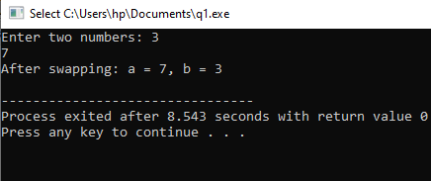

Q2. Execute a C++ Program to check whether a Character is Vowel or Consonant
#include <iostream>
using namespace std;
int main() {
char c;
cout << "Enter a character: ";
cin >> c;
if (c=='a'||c=='e'||c=='i'||c=='o'||c=='u'||
c=='A'||c=='E'||c=='I'||c=='O'||c=='U')
cout << c << " is a vowel.";
else
cout << c << " is a consonant.";
return 0;
}
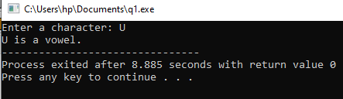

Q3. Execute a C++ program to check the sum of Natural numbers
#include <iostream>
using namespace std;
int main() {
int n, sum = 0;
cout << "Enter a positive integer: ";
cin >> n;
for (int i = 1; i <= n; ++i)
sum += i;
cout << "Sum = " << sum;
return 0;
}
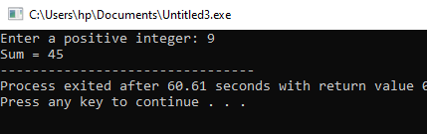

Q4. Execute a C++ program to calculate the power of a Number
#include <iostream>
#include <cmath>
using namespace std;
int main() {
double base, exponent, result;
cout << "Enter base and exponent: ";
cin >> base >> exponent;
result = pow(base, exponent);
cout << base << " raised to power " << exponent << " = " << result;
return 0;
}
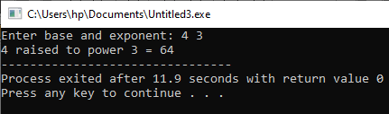

Q5. Execute a C++ program to check whether the number is Even or Odd
#include <iostream>
using namespace std;
int main() {
int num;
cout << "Enter an integer: ";
cin >> num;
if (num % 2 == 0)
cout << num << " is even.";
else
cout << num << " is odd.";
return 0;
}
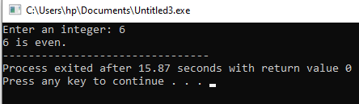
Q6. Execute a C++ Program to Add two Integers
#include <iostream>
using namespace std;
int main() {
int a, b, sum;
cout << "Enter two numbers: ";
cin >> a >> b;
sum = a + b;
cout << "Sum = " << sum;
return 0;
}
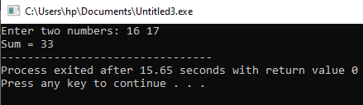

Q7. Execute a C++ Program to Print Number entered by user
#include <iostream>
using namespace std;
int main() {
int num;
cout << "Enter a number: ";
cin >> num;
cout << "You entered: " << num;
return 0;
}
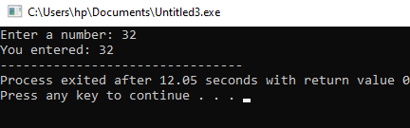

Q8. Execute a C++ Program to Print “Hello World”
#include <iostream>
using namespace std;
int main() {
cout << "Hello World";
return 0;
}